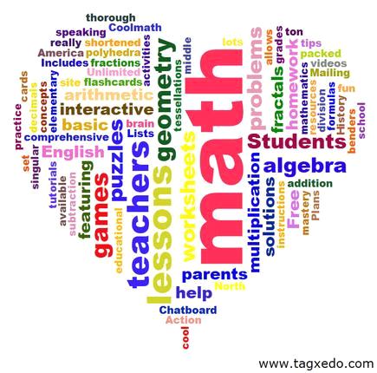 **Basic Math**

**Syllabus**

The purpose of this class is to introduce real world mathematics that will help improve the student’s understanding of math and how they can apply it in their life. In this class we will be going at the student’s rate of understanding in order reinforce basic mathematical concepts and give real life examples of practical math in everyday living. In this class we will be covering:

* **Fractions**
* **Money Sense**
* **Basic Addition, Subtraction, Multiplication, and Division**
* **Time**
* **Place Values**
* **Graphs and Charts**
* **Order of Operations (PEMDAS)**
* **Measuring**
* **Estimating**

As we cover these topics, we will be doing projects, group activities and games as well as worksheets and board work in order to encompass all forms of learning styles.

Each student will need: Pencil, paper, eraser and a basic folder for the class.